Divide-Answers
Key Stage 3: 2003 Paper 1 Level 3-5
1.
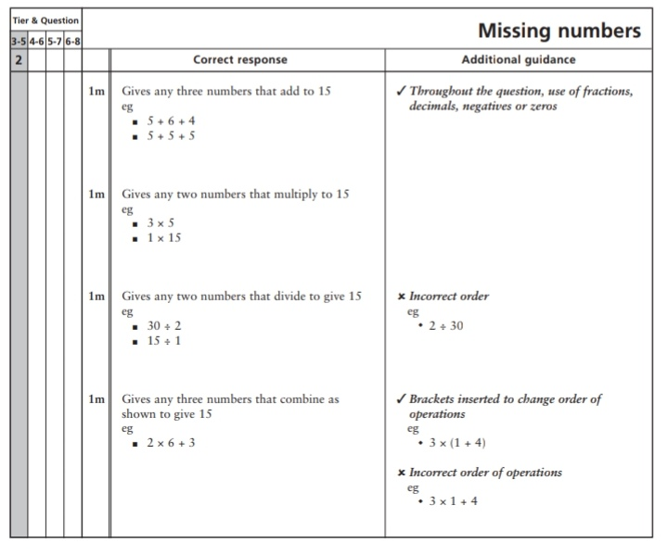

2.
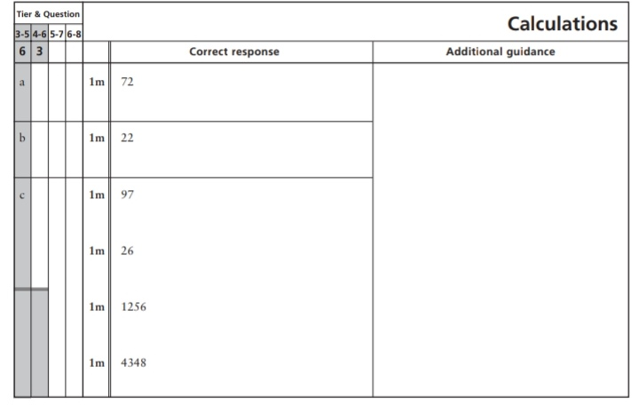
3.
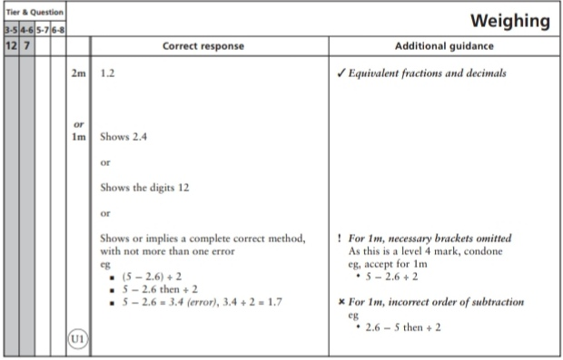

4.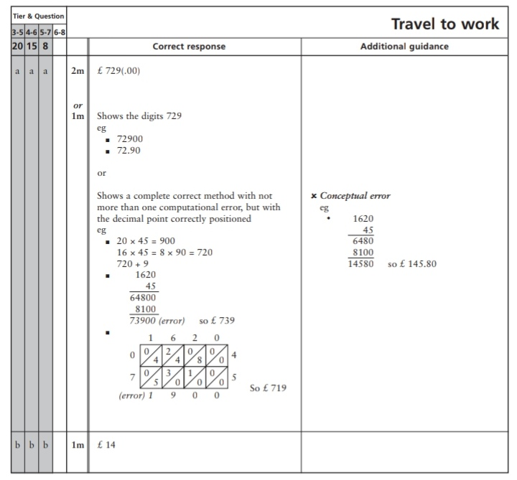
Key Stage 3: 2003 Paper 1 Level 4-6
5.
6.
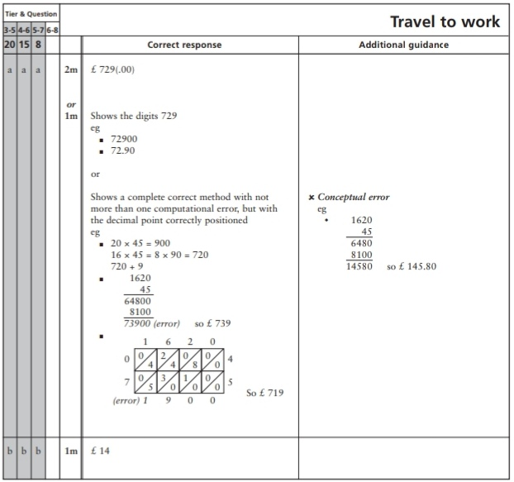
Key Stage 3: 2004 Paper 1 Level 3-5
7.
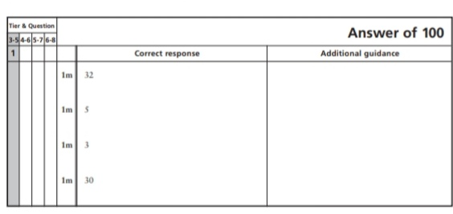
8.
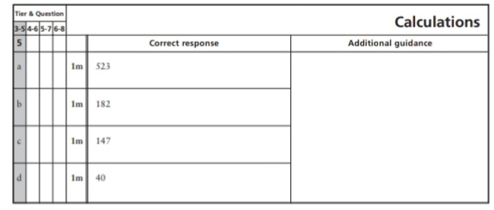
9.
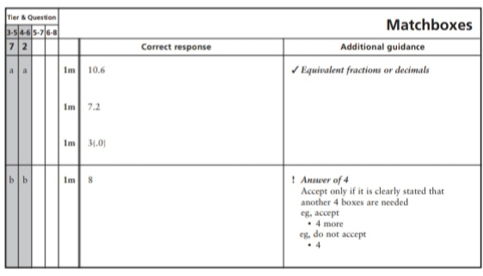
10.
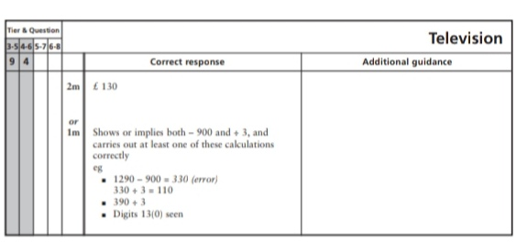
Key Stage 3: 2004 Paper 2 Level 3-5
11.
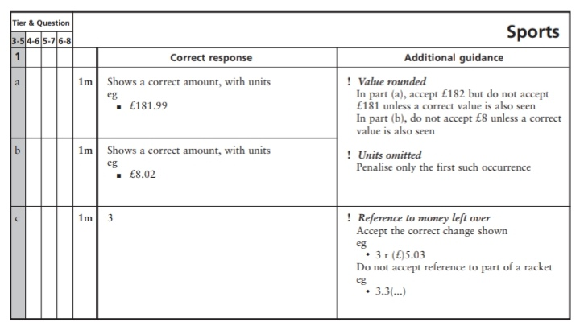
Key Stage 3: 2004 Paper 1 Level 4-6
12.
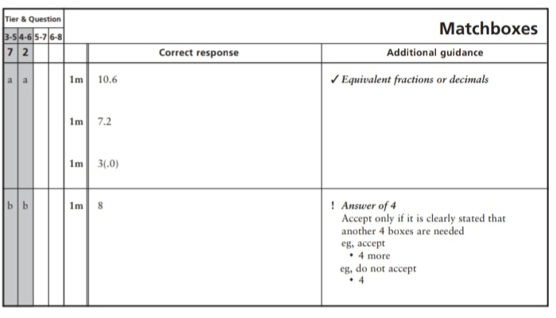
13.
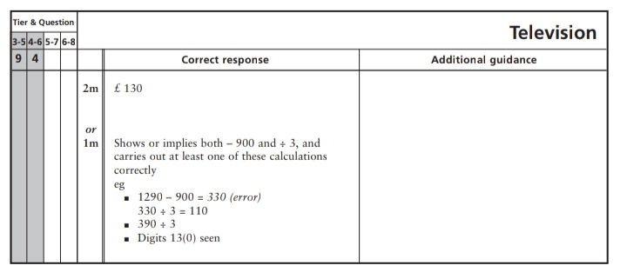
Key Stage 3: 2005 Paper 1 Level 3-5
14.
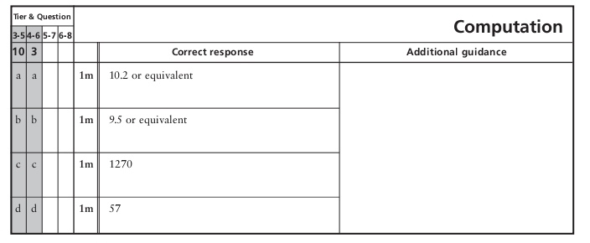
Key Stage 3: 2005 Paper 2 Level 3-5
15.
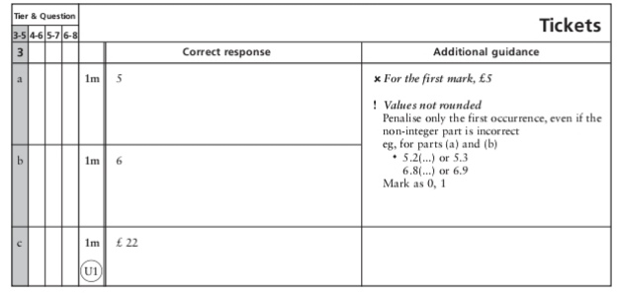
16.
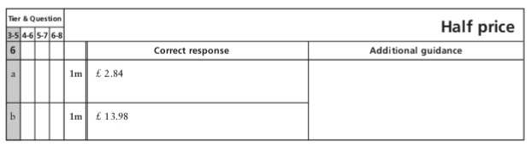
17.
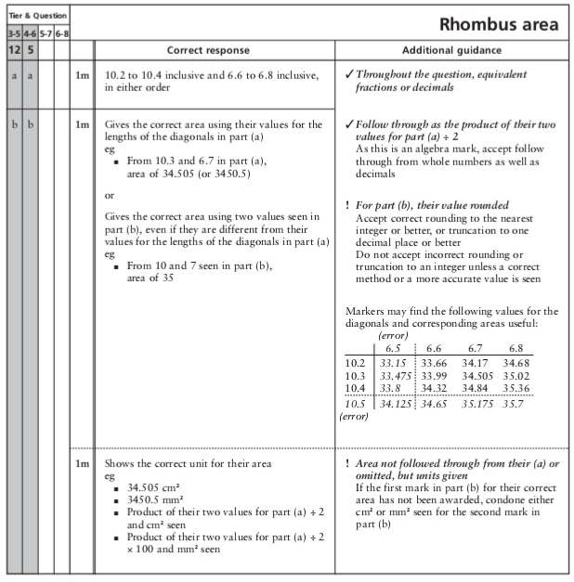
18.
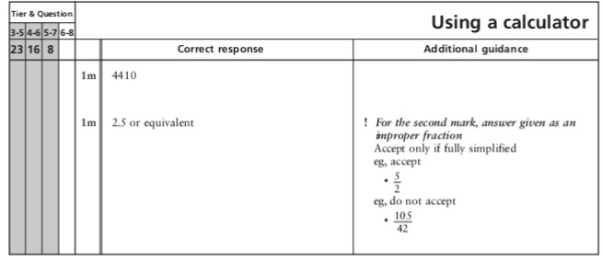
Key Stage 3: 2005 Paper 1 Level 4-6
19.
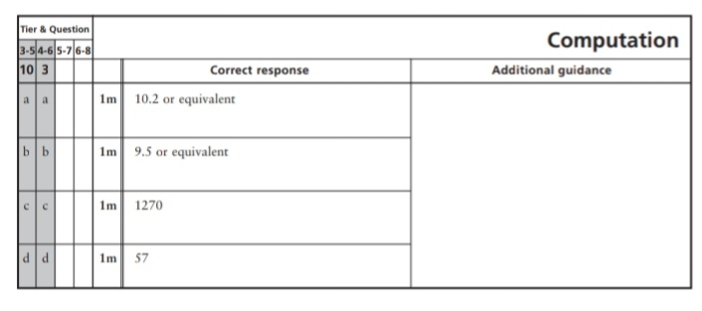
Key Stage 3: 2005 Paper 2 Level 4-6
20.
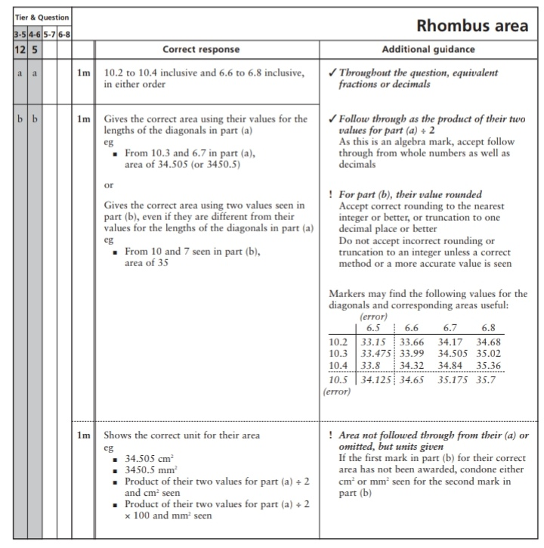
21.
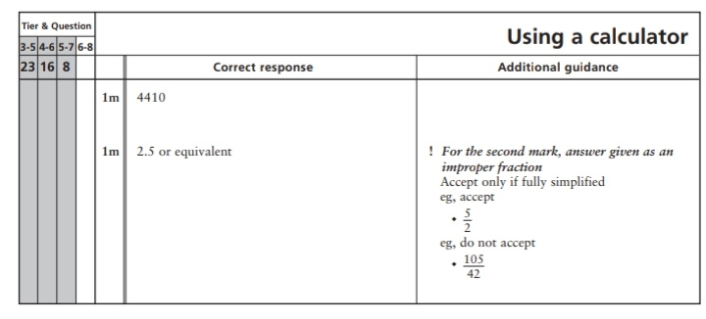
Key Stage 3: 2006 Paper 1 Level 3-5
22.
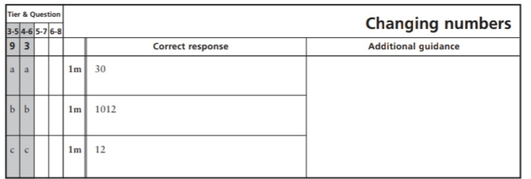
23.
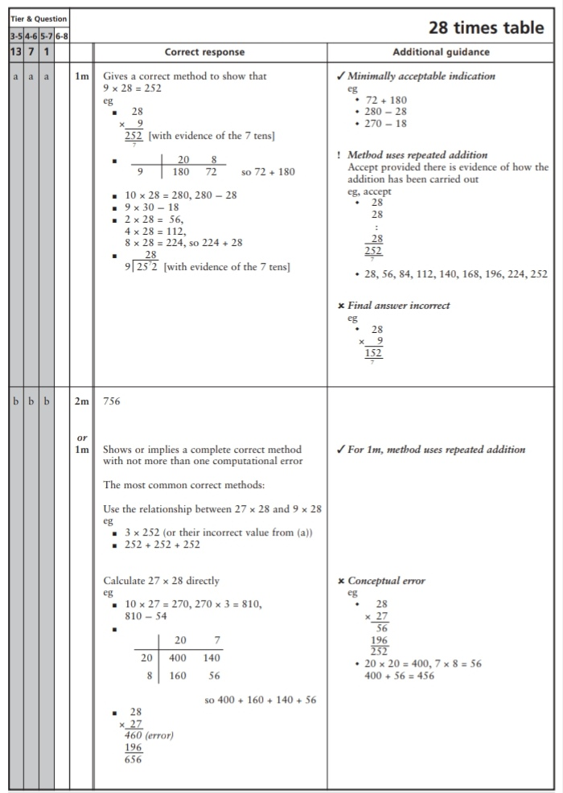
Key Stage 3: 2006 Paper 2 Level 3-5
24.
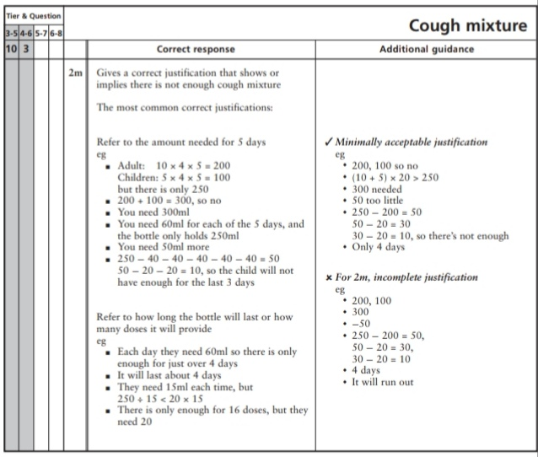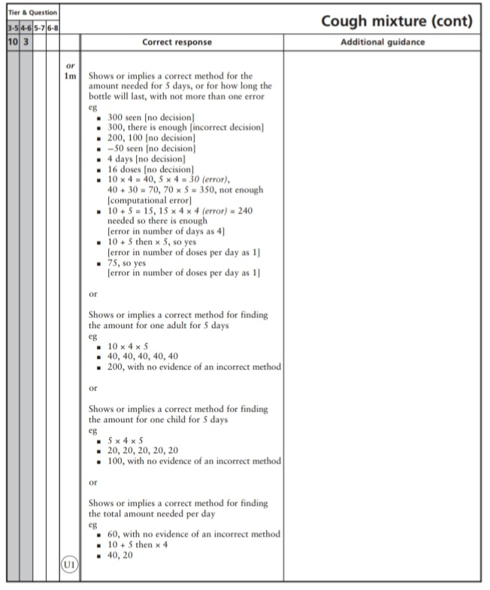
25.
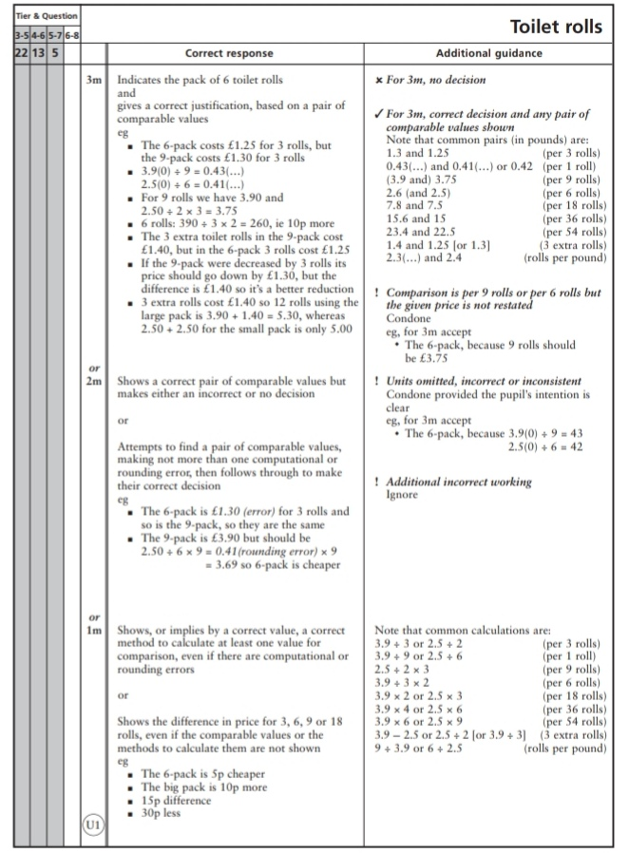
Key Stage 3: 2006 Paper 1 Level 4-6
26.
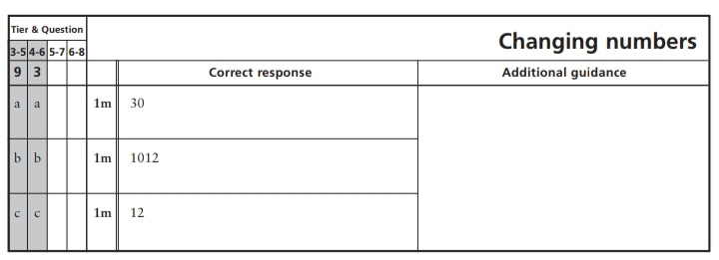
27.
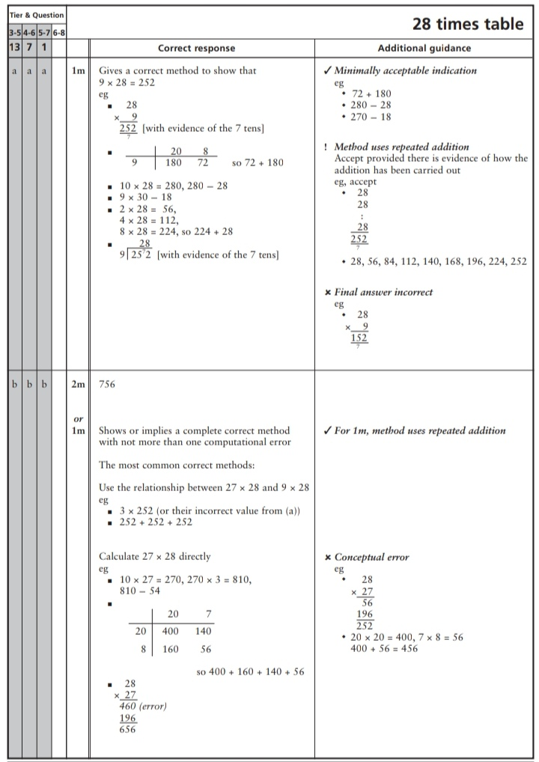
Key Stage 3: 2006 Paper 2 Level 4-6
28.
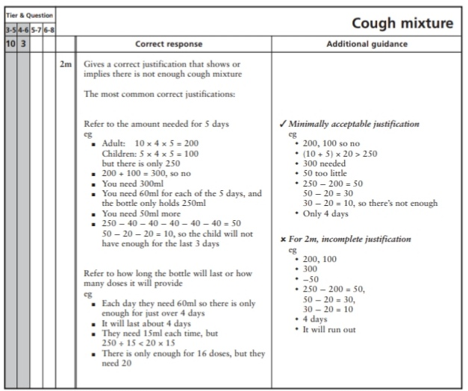
29.
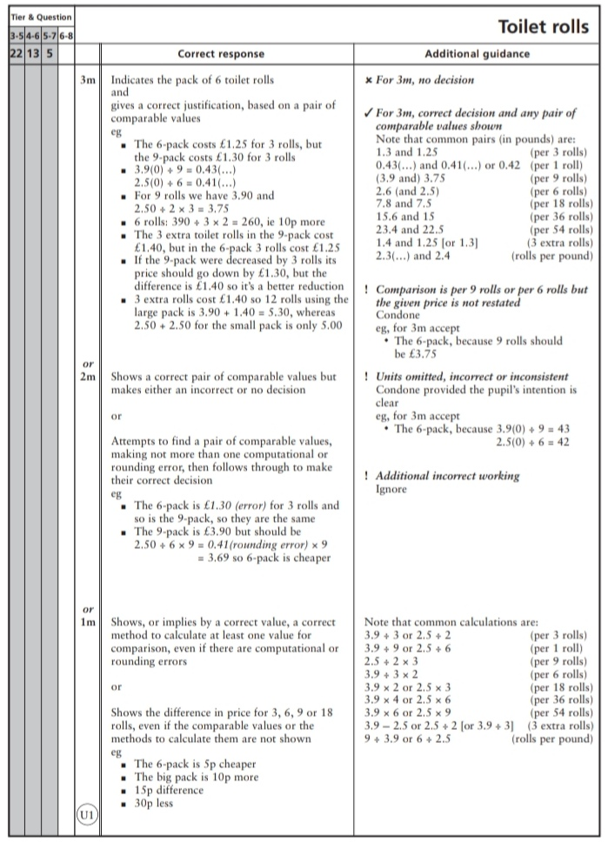
Key Stage 3: 2007 Paper 1 Level 3-5
30.
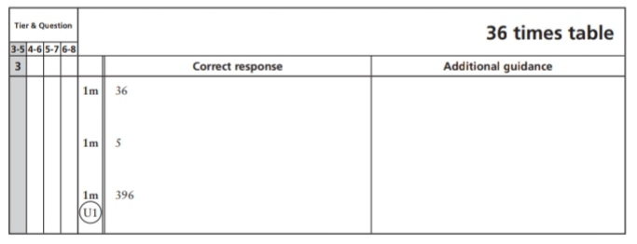
Key Stage 3: 2007 Paper 2 Level 3-5
31.
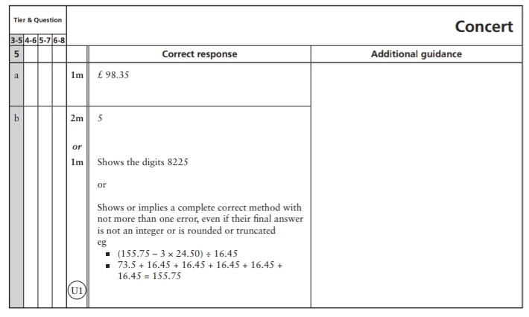
32.
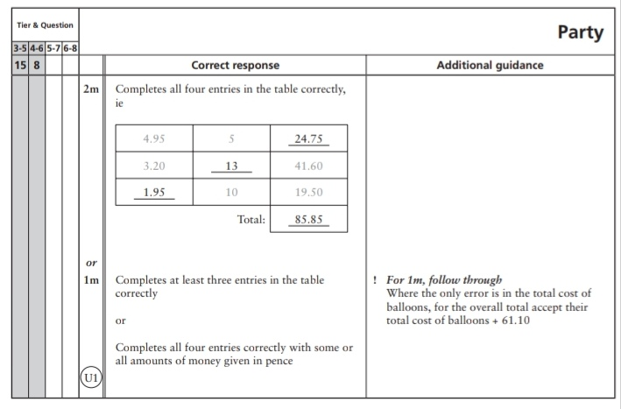
33.
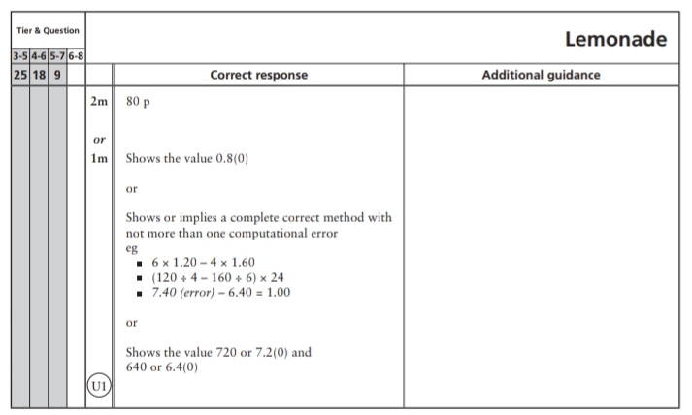
Key Stage 3: 2007 Paper 2 Level 4-6
34.
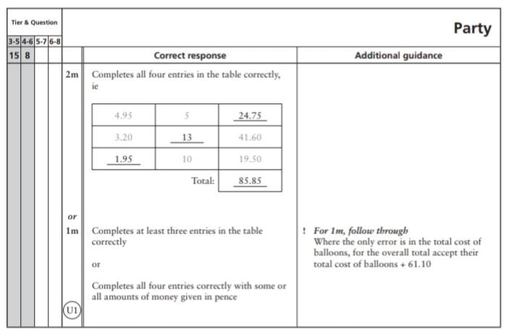
35.
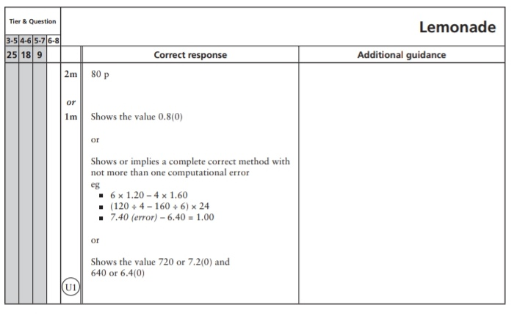
Key Stage 3: 2008 Paper 1 Level 3-5
36.
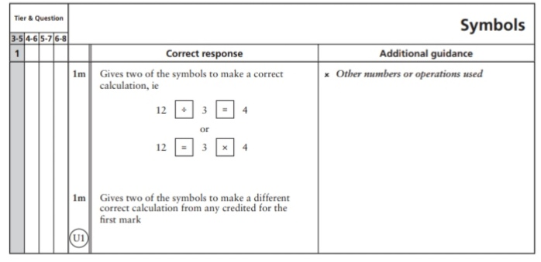
37.
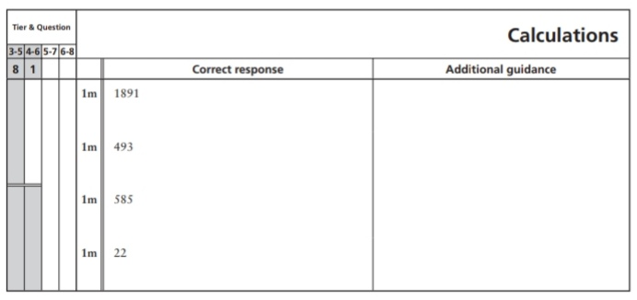
38.
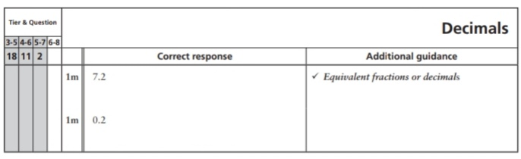
Key Stage 3: 2008 Paper 1 Level 4-6
39.
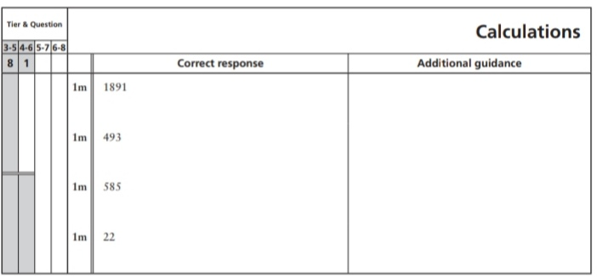
40.
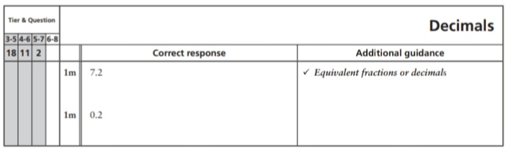
Key Stage 3: 2009 Paper 1 Level 3-5
41.
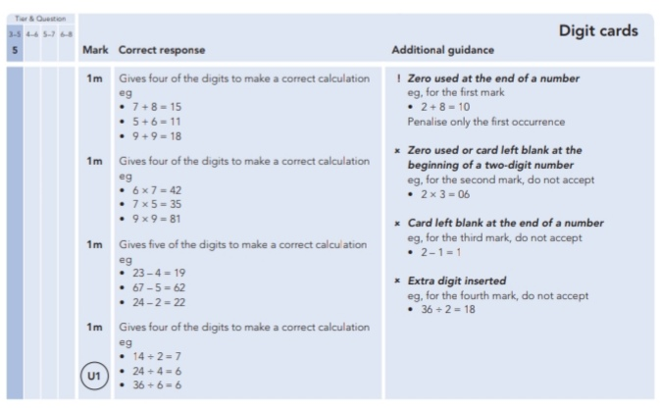
42.
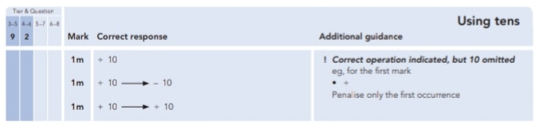
Key Stage 3: 2009 Paper 2 Level 3-5
43.
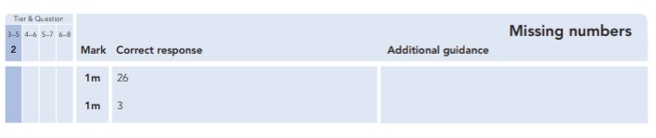
Key Stage 3: 2009 Paper 1 Level 4-6
44.
Key Stage 3: 2010 Paper 1 Level 3-5
45.
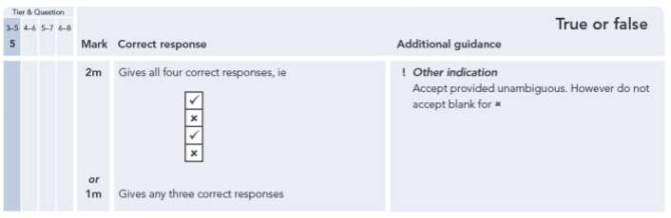
46.
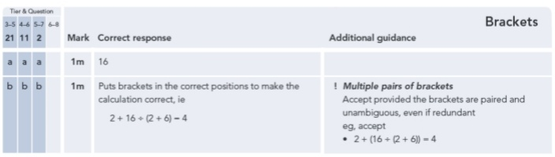
Key Stage 3: 2010 Paper 2 Level 3-5
47.
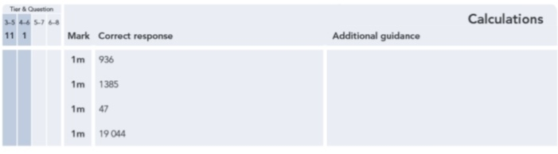
Key Stage 3: 2010 Paper 1 Level 4-6
48.
Key Stage 3: 2010 Paper 2 Level 4-6
49.
50.
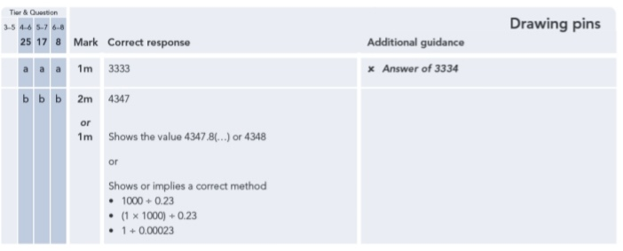
Key Stage 3: 2011 Paper 2 Level 4-6
51.
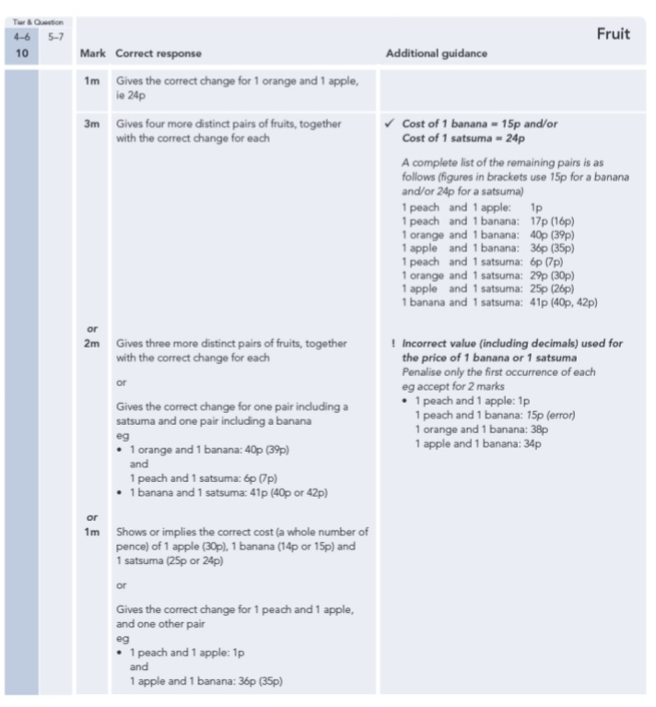
52.
